Problem statement
A leading retail company wants to better understand its customers’ shopping behavior to improve sales, customer satisfaction, and long-term loyalty. The management team has noticed changes in purchasing pattern across demographics, product categories, and sales channels (online vs. Offline). They are particularly interested in uncovering which factors, such as discounts, reviews, seasons or payment preferences, drive customers’ decisions and repeat purchase.
How can the company leverage consumer shopping data to identify trends, improve customer engagement and optimize marketing and product strategies?
The dataset contains 3.9k customer purchase records with the following major dimensions:
Customer & Demographics
- Customer ID
- Age
- Gender
- Location
Product & Purchase
- Item Purchased
- Category
- Size, Color
- Season
- Purchase Amount (USD)
Behavior & Engagement
- Frequency of Purchases
- Previous Purchases
- Review Rating
- Promo Code Used
- Discount Applied
- Shipping Type
- Payment Method
This structure is ideal for sales performance, customer behavior, and marketing effectiveness analysis.

Deliverables
- Data preparation & modeling (Sql Server): clean and transform the raw dataset for analysis
- Data Analysis (SQL): Organize the data into a structured format, simulate business transactions, and run queries to extract insights on customer segments, loyalty and purchase drivers.
- Visualization and Insights (Power Bi): build an interactive dashboard that highlights the patterns and trends, enabling stakeholders to make data-driven decisions.
- Report and presentation: write a clear project report summarizing your key finds and business recommendations. Prepare a presentation that visually communicates insights and actionable recommendations to stakeholders
- GitHub Repository: Include all python scripts, SQL queries and dashboard files in a well-structured rep
Exploratory Data Analysis Using My SQL Server
I began by loading the data for cleaning and exploratory in My SQL Server
- To initiate- decided to view and check the information statistics of the data.
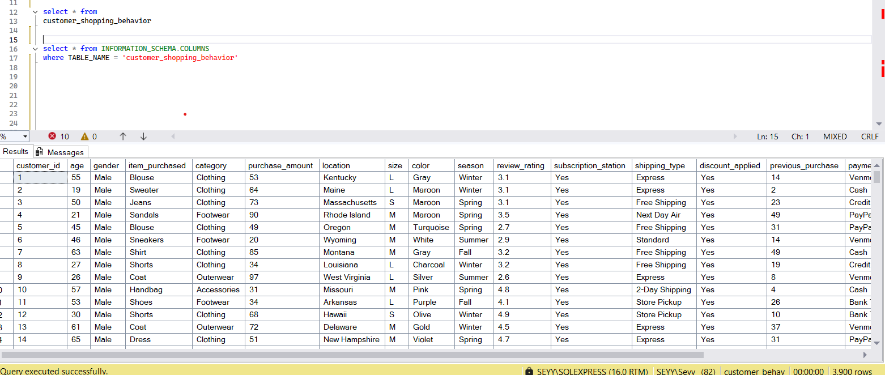

Rename the columns: decided to rename the columns names with snake format for easy calling and verify the col changes
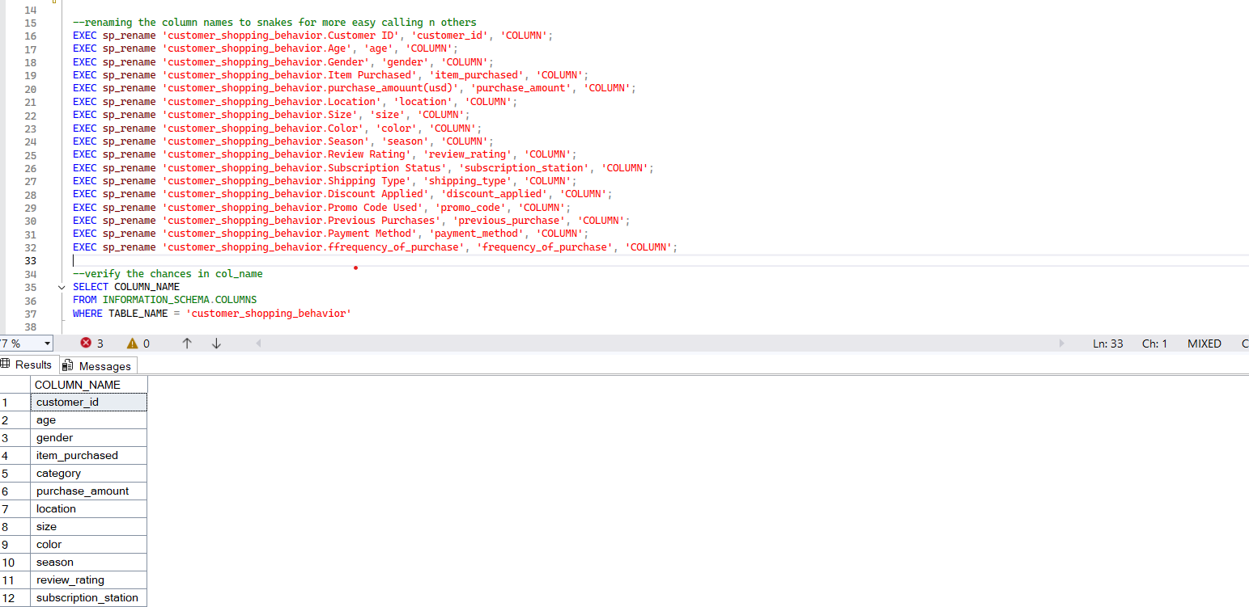

Checking for Duplicates: Checking for row/ value duplicates
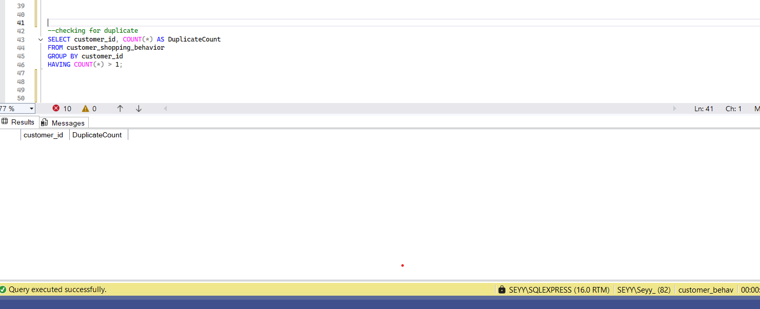

Trimmed selected columns and updated the table and verified the changes in the made exec
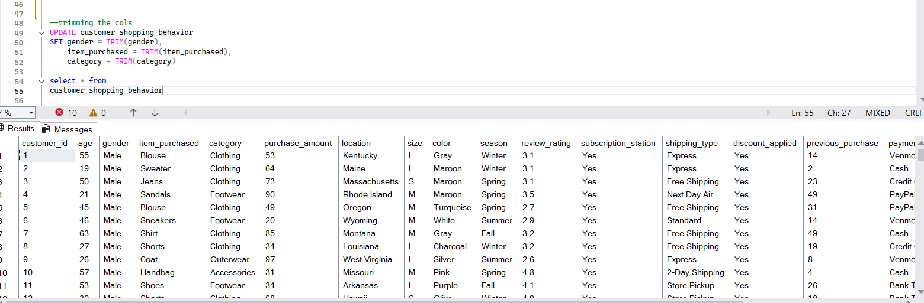

Null Checking: Checking Each Col for Null Values and finding how many nulls are the found col
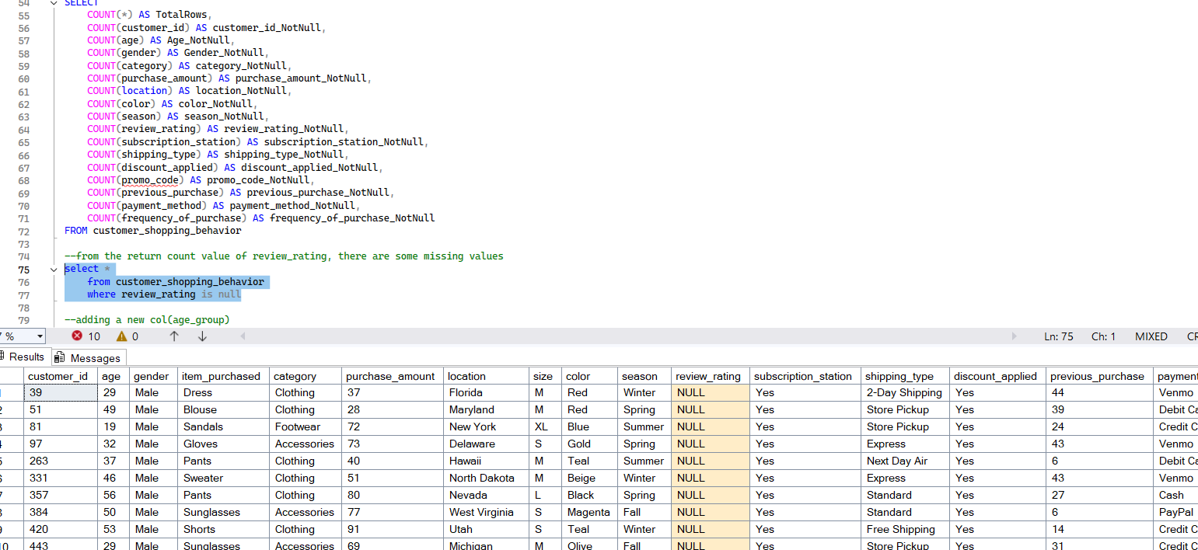

New Column: created a new col(age_group) and group it by the age with certain age range(age_group) and update it into the new col
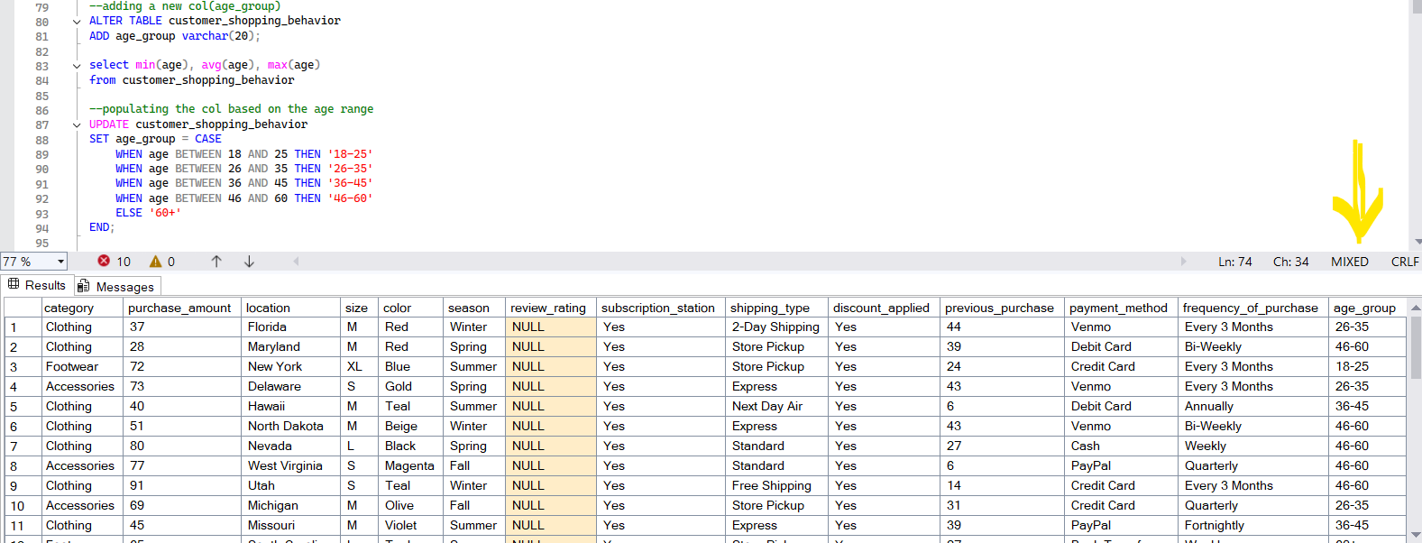

Redundancy : checking, match data col and remove any redundancy
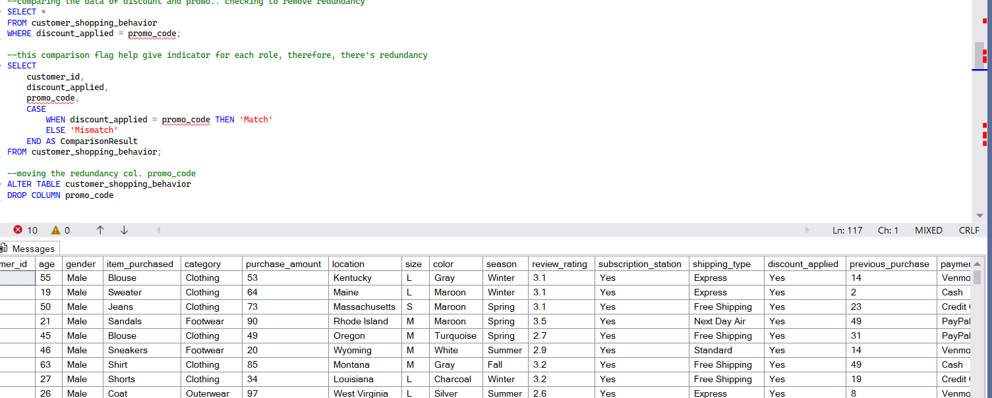

Exploratory Analysis
- Revenue by Gender
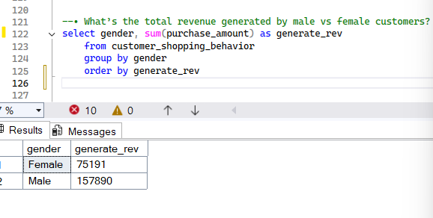

- Avg Revenue x discount applied
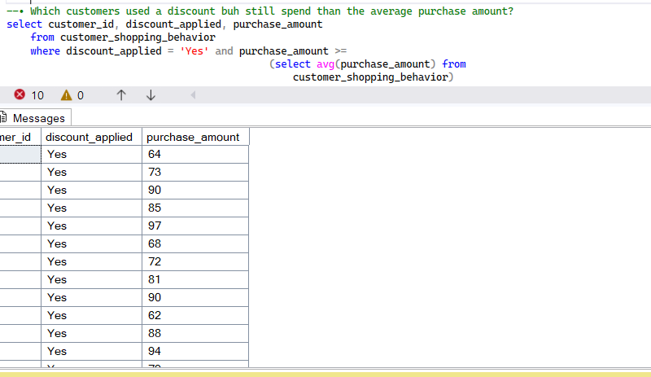

- Avg Review rating of Top 5 products
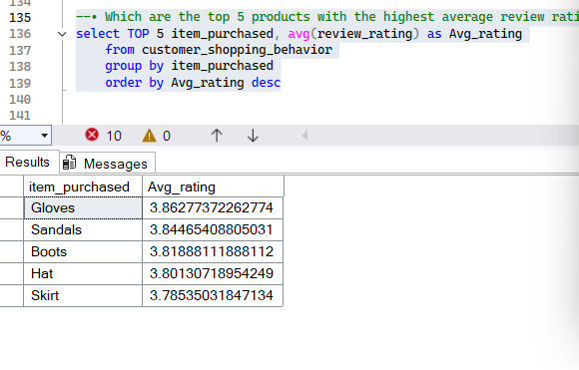

- Avg Revenue derived via standard and express shipping
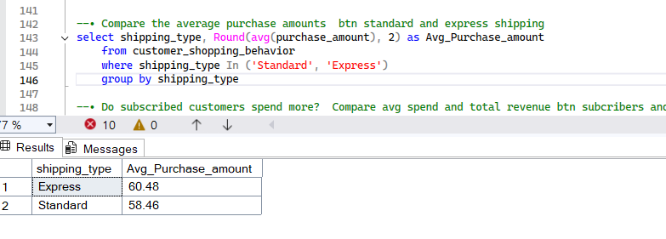

- With subscription statue-provide the avg revenue and total revenue no of customers
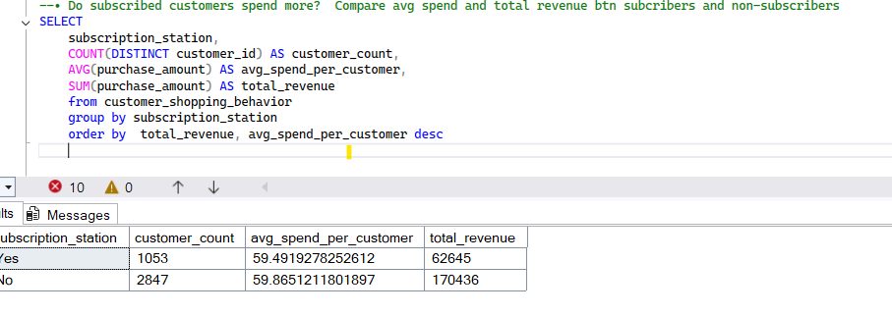

- Product with highest discount_applied(percentage %)
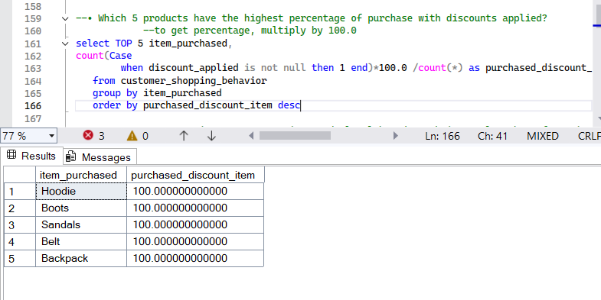
- Customer by Previous-purchase
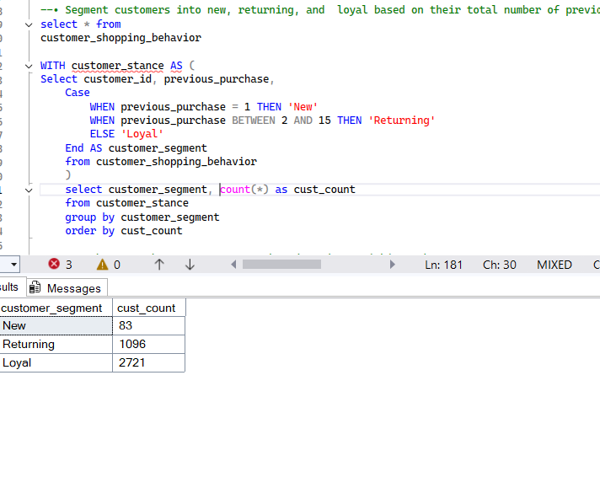
- Top 3 purchase product by category
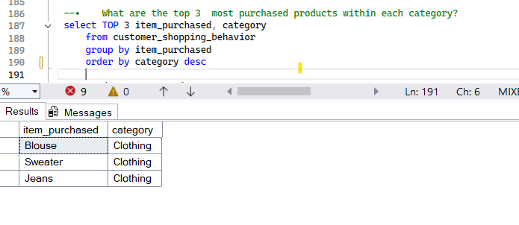

TRACKING CUSTOMER SHOPPING DASHBOARD
Below is a complete, structured deliverable that combines:
- Power BI wireframe layout (page-by-page, visual-by-visual)
- All KPIs with their exact Power BI DAX measures, organized in the same order as the dashboard

These are measures created
- Total_Revenue = SUM(customer_shopping_behavior[purchase_amount])
- Total_order = COUNT(customer_shopping_behavior[item_purchased])
- Total_customers = DISTINCTCOUNT(customer_shopping_behavior[customer_id])
- Avg_rating review = AVERAGE(customer_shopping_behavior[review_rating])
- Repeat_Purchase Rate(%) = DIVIDE(
- CALCULATE(
- DISTINCTCOUNT(customer_shopping_behavior[customer_id]), customer_shopping_behavior[previous_purchase] >0),
- [Total_customers])
- Average_Order = DIVIDE([Total_Revenue], [Total_order])

Below are Created Dashboard
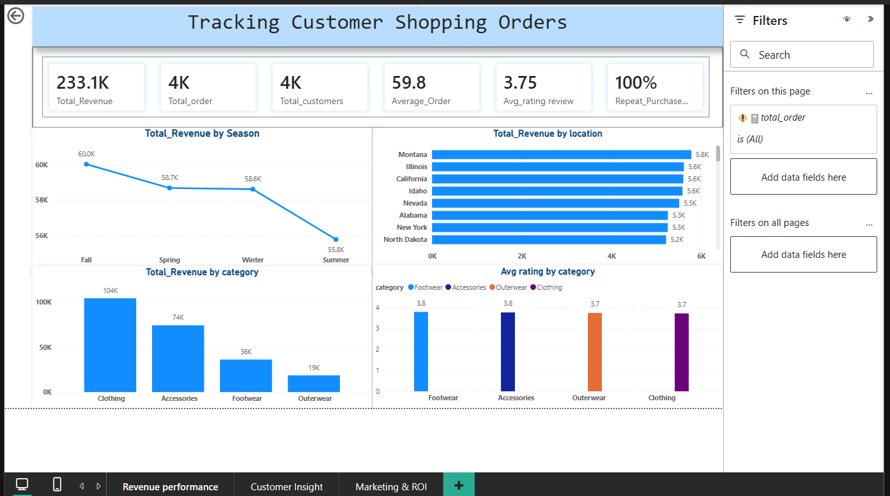
6 KPI Cards in a single row:
Total Revenue
Total Customers
Average Order Value
Total Orders
Repeat Purchase Rate (%)
Average Review Rating

Revenue Performance
Total Revenue by location(chart)
Revenue by Season (Line Chart)
Revenue by Category (Bar Chart)
Average Rating by Rate review (Bar chart)

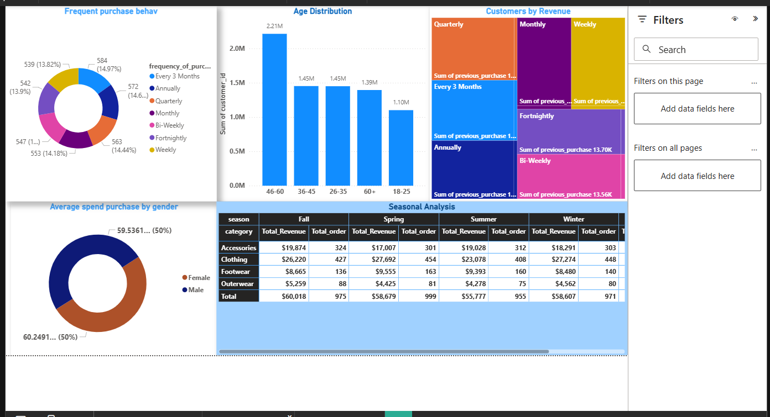
Purchase Behavior
Customer Age Distribution(Column Chart)
Average Spend by Gender(Bar Chart)
Frequency of Purchases (Weekly, Monthly, Fortnightly, Annually)-(Donut Chart)
Seasonality analysis (category, season-total revenue, total orders)
Top 7 Customers by Revenue (Customer ID, Total Revenue, Previous Purchases, Frequency of Purchases)

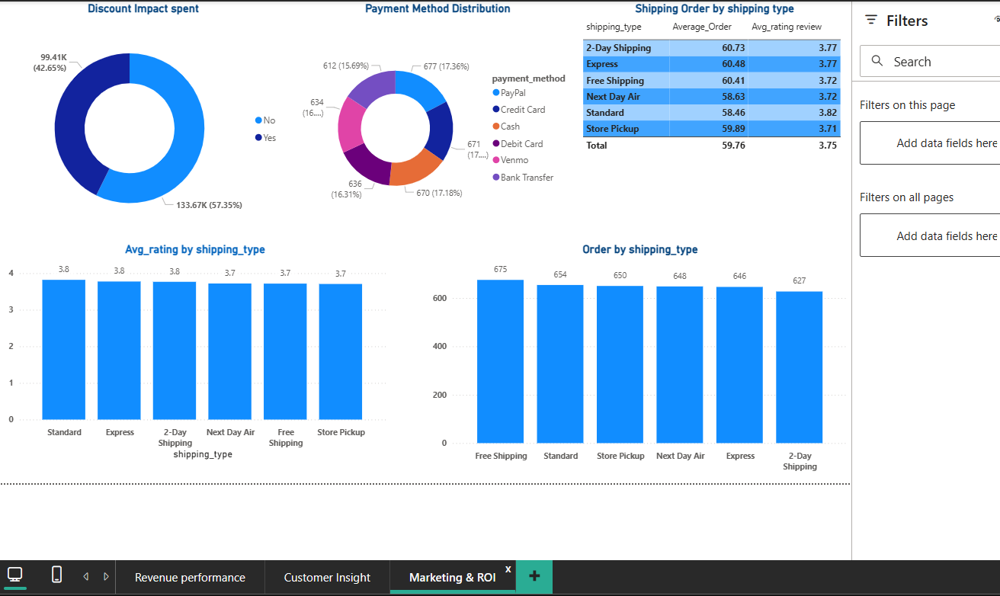

Average Review Rating by Category(Bar chart)
Most performed Payment Method
Shipping order by shipping type
Discount Usage Rate reviewing (%)
Average Review Rating by Shipping Type(Bar chart)

